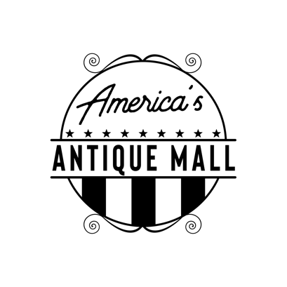
Dealer Application

Name: _______________________ Phone: _________________ Email:________________________
Did an AAM Dealer refer you?  Yes  No If Yes, whom? __________________________
Do you own your own antiques shop?  Yes  No
Do you lease space in other malls?  Yes  No
I am interested in:  Booth  Locked Showcase  Open Shelf
Please list the type of merchandise you would like to sell here:
1. | 4.
2. | 5.
3. | 6.

How did you hear about us: _____________________________________________________________________

America’s Antique Mall reserves the right to limit certain items to ensure a broad mix of antiques and collectibles.
The Numbers
- Floor spaces are $2.25 per square foot
- Locked cases start at $100/month
- Shelf Spaces start at $59/month
- 12% mall commissions
- No credit card fees

Cares Act Dealer Promotional Rate
Example for standard 10 X 10 booth
June – Aug 75% off $225 = $56.25 (plus tax)
Sept – Nov 50% off $225 = $112.00 (plus tax)
Dec – Feb 25% off $225 = $169.00 (plus tax)
Full retail services provided to dealers:
- Consistent & timely dealer payments
- Clean & secure store with state of the art security camera system,
- Consigner Access – online inventory system
- Helpful & friendly staff focused on exceptional customer service
- Multifaceted marketing & large advertising budget

America’s Antique Mall is professionally managed and committed to the long-term success of our store and our dealers.
Join the America’s Antique Mall Family of Dealers.
- Earn income doing something fun & enjoyable
- Be a small business owner with partners who support you
- Learn from others who love antiques, vintage furniture, and collectibles
- Be a part of a diverse and welcoming community

